Design Options

# Resources/DO%201/Window%203.pngResources/DO%201/Window%202.pngResources/DO%201/Window%201.pngResources/DO%201/Referencing%20Table.pngResources/DO%201/Export%20Screen.pngResources/DO%201/Browser.pngDesign Option 1

# Resources/DO%202/Window%202.pngResources/DO%202/Window%201.pngResources/DO%202/Referencing%20Table.pngResources/DO%202/Browser.pngDesign Option 2

# Resources/DO%203/Browser.pngResources/DO%203/Referencing%20Table.pngResources/DO%203/Window%201.pngResources/DO%203/Window%202.pngResources/DO%203/Window%203.pngDesign Option 3

# Design Option Criteria

**Design Option 3**

|  |  |
| --- | --- |
| **Pros** | **Cons** |
| Colour pallet | Redundant features |
| Easy to understand | Missing key features |
| Concise |  |

**Design Option 2**

|  |  |
| --- | --- |
| **Pros** | **Cons** |
| Colour pallet | Hard to understand |
|  | Blocky |

**Design Option 1**

|  |  |
| --- | --- |
| **Pros** | **Cons** |
| *Effective* | *Blocky* |
| *Fast* | *Hard to understand* |
| *Concise* | *Colour pallet* |

|  |  |  |  |
| --- | --- | --- | --- |
| Criteria | Design Option 1 | Design Option 2 | Design Option 3 |
| Speed of Operation | 7 / 10 | 8 / 10 | 9 / 10 |
| Ease of Use | 7 / 10 | 7 / 10 | 10 / 10 |
| Readability | 3 / 5 | 3 / 5 | 4 / 5 |
| Attractiveness | 3 / 5 | 4 / 5 | 5 / 5 |
| Accessibility | 3 / 5 | 4 / 5 | 4 / 5 |
| Usability | 3 / 5 | 2 / 5 | 4 / 5 |
| Total | 26 / 40 | 28 / 40 | 36 / 40 |

Design Option Criteria Table

## Comments // Continuance of Design – Reasons

I have decided to redo the design due to the feedback I’ve received from features of the past designs. I believe I can design a solution that will be able to score higher than the current highest scorer (36/40), and be able to produce a more effective solution.

## Written Descriptions

### Design Option 1:

This design has a large emphasis on ease of use, simplicity and monochromatic colour pallets.

I chose this because I wanted this design to be as clean and simple as possible, with design constraints coming from older versions of Windows. The reason for this is because I wanted the user to feel a sense of familiarity when opening and using the program

### Design Option 2:

This design borrowed features heavily from Design Option 1 and Design Option 2. Here, I tried to merge the two designs, combining the colour pallet, Flat UI design and emphasis on ease of use. The users that gave me feedback on this design alerted me that this didn’t come though as planned.

### Design Option 3:

Design Option 3 was heavily influenced on the Flat UI movement – which is another take on simplicity. Here, I tried to make the solution as simple as possible, whistle not sacrificing crucial features that the solution needs to be effective, like a large web browser, and readable and reliable referencing table.

Although this design has a much larger range of functionality windows, it makes the workflow easier, as users don’t have to think about what they are needing to do in each window – rather, its more spelled out for them with a step by step workflow. I decided this was needed through the answer I received on a survey, alluding that High School students may not fully understand how to reference, and need a more user-friendly workflow to help teach them.

# Resources/Images-UXPin-Design_Option__4%20Preferred%20Option%20-Export/Browser.pngResources/Images-UXPin-Design_Option__4%20Preferred%20Option%20-Export/Window%203.pngResources/Images-UXPin-Design_Option__4%20Preferred%20Option%20-Export/Window%202.pngResources/Images-UXPin-Design_Option__4%20Preferred%20Option%20-Export/Window%201.pngRemodelled Design

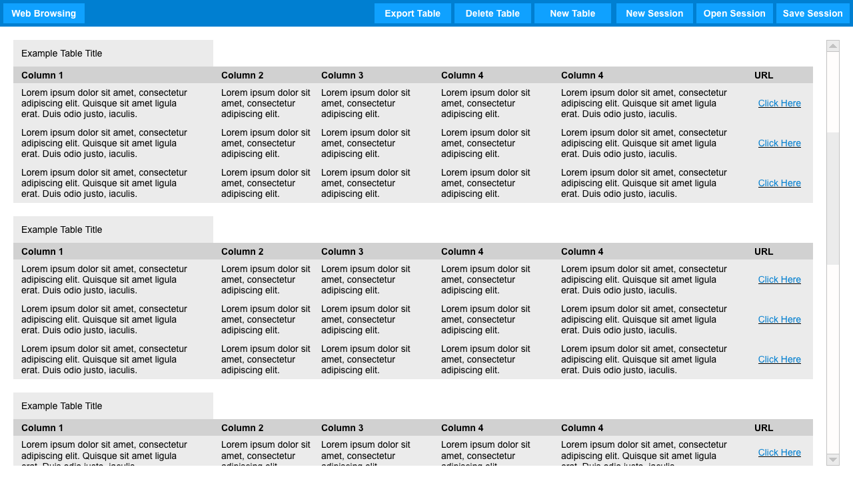

## Remodelled Design Score

## Remodelled Design Reflection

I am glad I made these changes – they have proven to make the solution a better option than previous options. Although it didn’t score the perfect score, I am able to live with this. I believe this allows for further improvement later on; it allows for user feedback and innovation.

## Remodelled Design Written Description

This design brings all of the features that users who tested and critiqued each of the first designs wanted, and shifted around others that may not have been effective where they were.

UI changes, like the movement of the URL bar and Referencing page menu occurred to give a more user friendly approach. Also, the colour pallet from

Overall through, this design is more of a revamp of Design Option 3, to allow it to better suit users, and be a more efficient solution.

|  |  |
| --- | --- |
| Criteria | Design Option 1 |
| Speed of Operation | 10 / 10 |
| Ease of Use | 10 / 10 |
| Readability | 4.5 / 5 |
| Attractiveness | 5 / 5 |
| Accessibility | 5 / 5 |
| Usability | 5 / 5 |
| Total | 39.5 / 40 |

Remodelled Design Score